**Creation Of a Business Partner and Contract Account**

**T Code:-**

**BP:** FPP1

**CA:** CAA1

**Business Partner:**

Step 1:

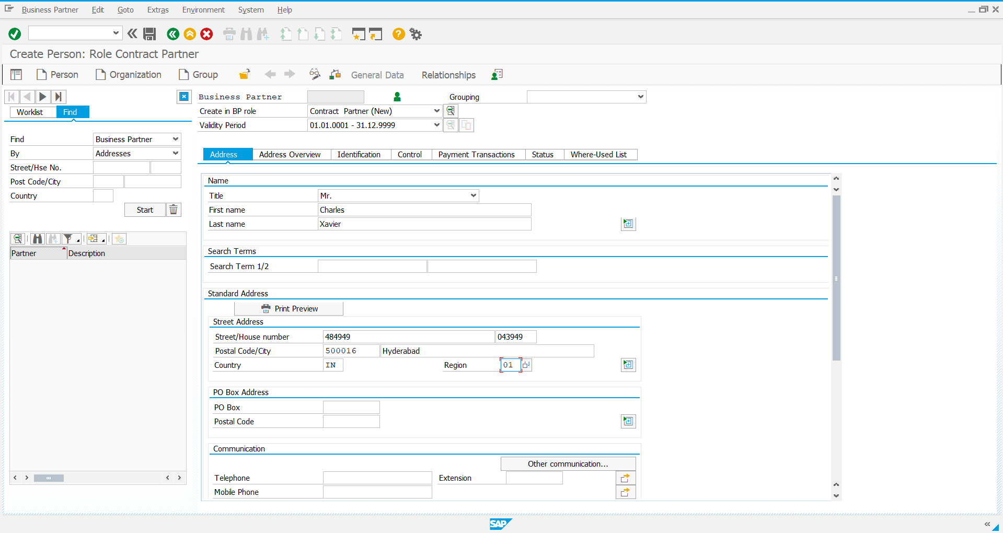

Step 2:

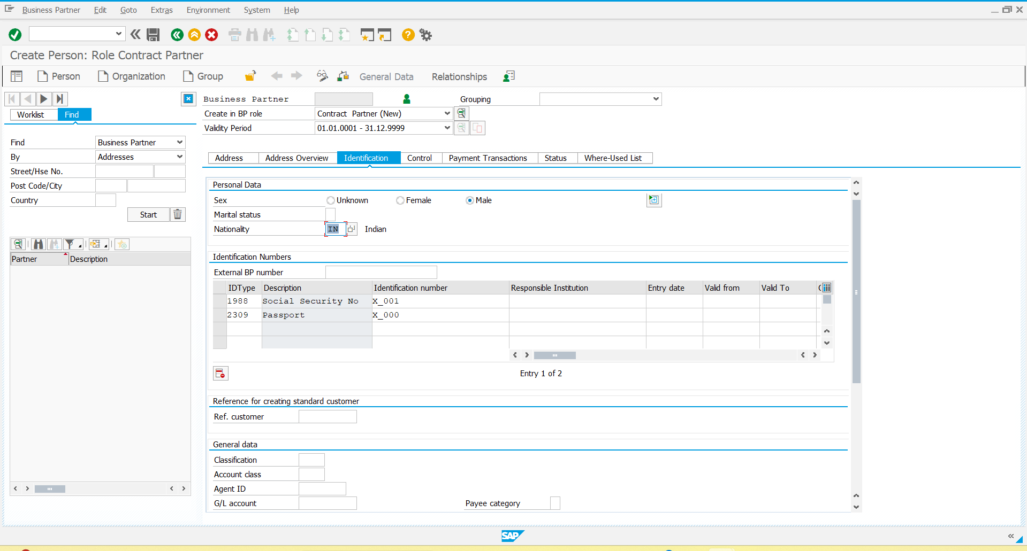

Step 3:

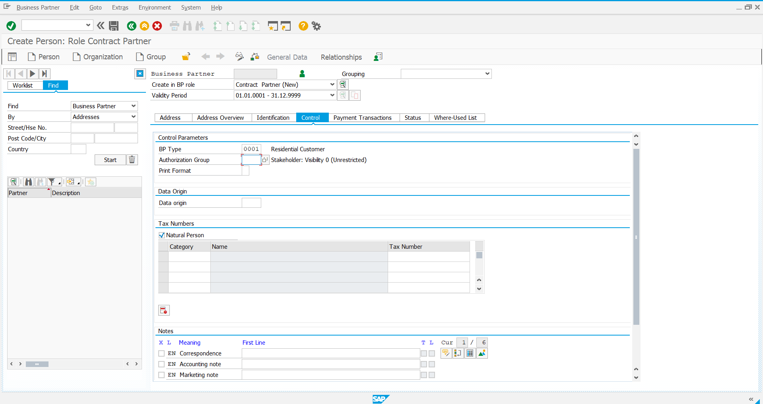

Step 4:

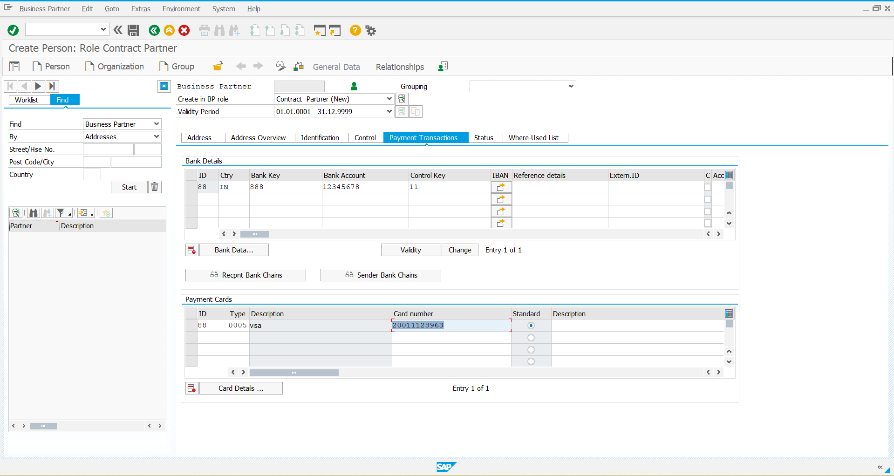

Step 5:

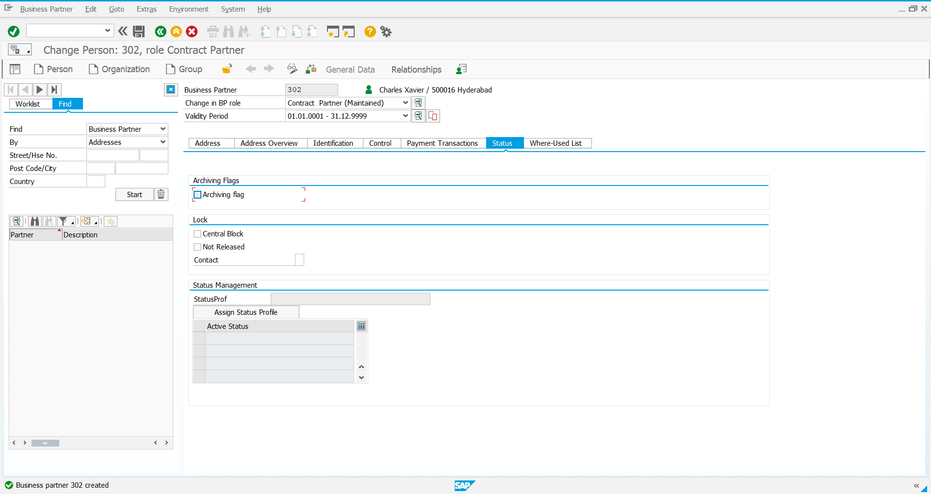

Created Business Partner Number: 302

**Contract Account**

Step 1:

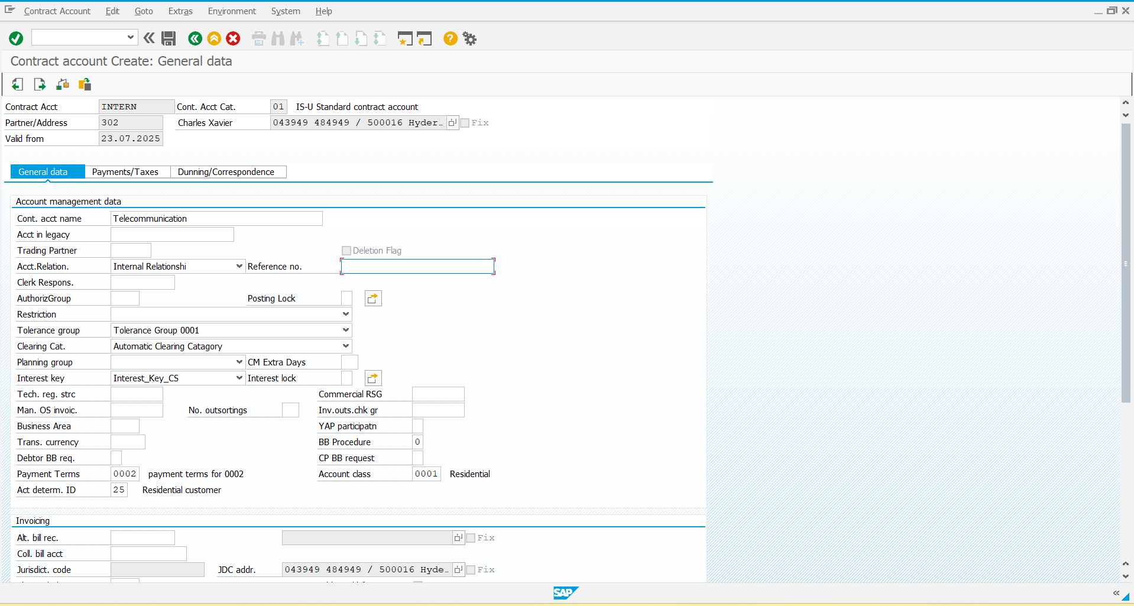

Step 2:

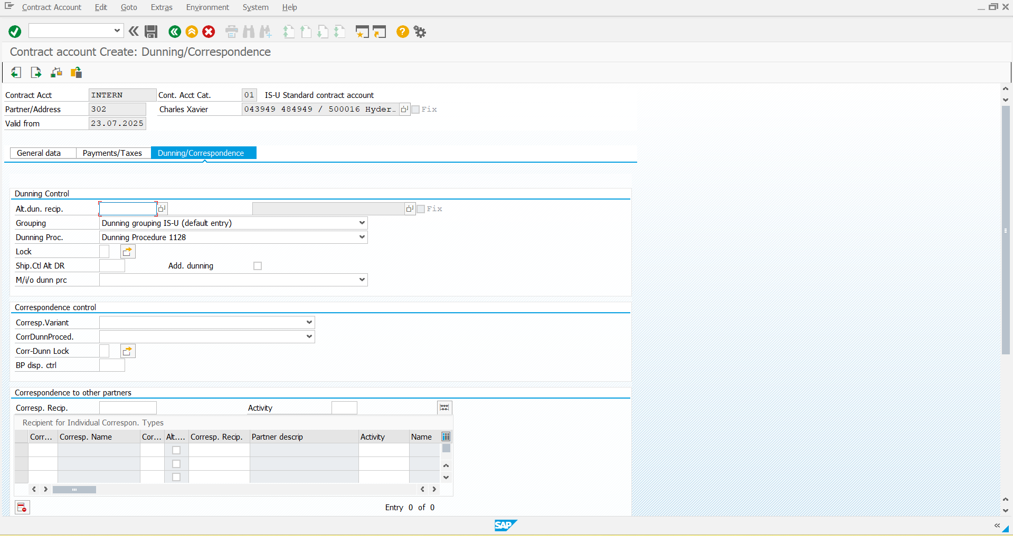

Step 3: After giving all the required details, save it and the CA is created

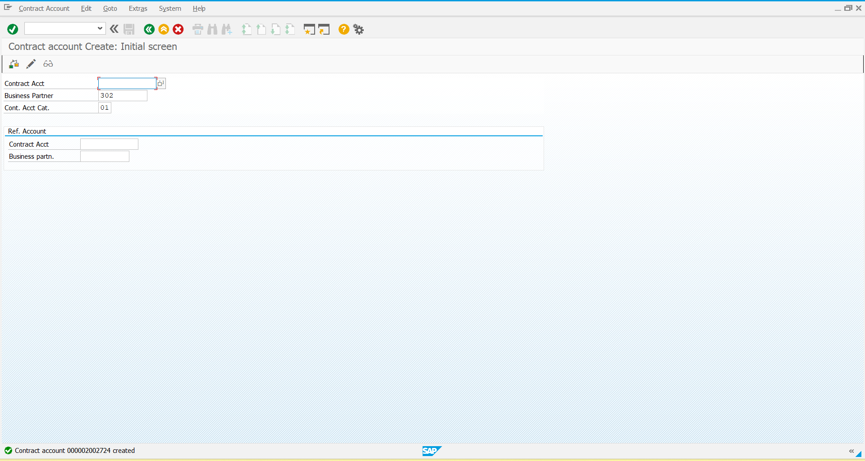

The Created CA number: 2002724